 |  | Title
  Caption (Photographer)  Caption (Photographer) |  | Lead (max. 500 Characters)  Main Text (max. 1000 Characters)  Facts and Figures  Text (max. 350 Characters)

Department of  Biomedical Engineering  Hegenheimermattweg  167b/C  CH – 4123 Allschwil  news-dbe@unibas.ch  www.dbe.unibas.ch  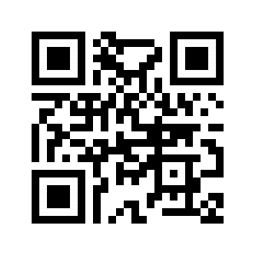 | Funding:   |  | Group Leaders:  Prof. Dr. Maximilian Master  maximilian.master@unibas.ch  Prof. Dr. Maximilian Master  maximilian.master@unibas.ch | References:  (1) Far far away, behind the word mountains, from the countries Vokalia and Consonantia, there a live the blind texts.  (2) Separated they live in Bookmarks-grove right at the coast of Semantics.  (3) It is a quite paradisematic country in which roasted parts of sentences fly  into your mouth. Even the all-powerful Pointing has no control about the blind texts. It is an almost unorthographic.

